**Critical Decision Making in National Educational Policy: Learning the Maths and Science in English, an Evaluation of Performance in Malaysia**

**Introduction**

Converting the medium of instruction from Bahasa Malaysia to English in national education policy of Malaysia was known to be an important issue to face the globalization as our local politicians have emphasized such conversion as an ultimate need in early year 2000. Giving priority to the teaching and learning processes of mathematics and science subjects in English language from primary to secondary and even furthered to territory levels in Malaysia become the core debate between academics, politicians and also among parents. After an arbitrary implementation of English language usage on the pedagogy and andragogy from the government sector, the conversion policies have taken effectiveness in the process since the end of year 2003. Within this framework of new idea, the textbooks, activity textbooks, teachers’ guide, my-cd developments, teachers-cd development, science practical books and glossary books are, consequently translated into English language for more than a million of students. However, to what extent this objective has achieved its goal among Malaysian students is an ambiguous after the completion of 10 solid years. This is an important issue to measure because the former deputy prime minister Tan Sri Muhyiddin Yassin who was also the then-education minister has cancelled the entire plan and reversed the decision as he had his own team of experts as to look after the matter (Tan Sri Muhyiddin Yassin, ‘baffled’ by Malaysians’ poor grasp of English – Malaymail News). As to see what has happened in this critical decision making process of Malaysian government is the primary aim of this report.

**Findings**

**1. Statistical data that taken by the education ministry of Malaysia from 2003 and 2007**

TIMSS (Trends in International Mathematics and Science Study) in collaboration with education ministry have conducted surveys for the performance of Mathematics and Science in Malaysia. The result shows that 2007 students are finding difficulties in achieving high grades as compared with 2003 results. Table 1 and 2 are obviously helping to compare these figures (TIMSS, Own Portal 2015).

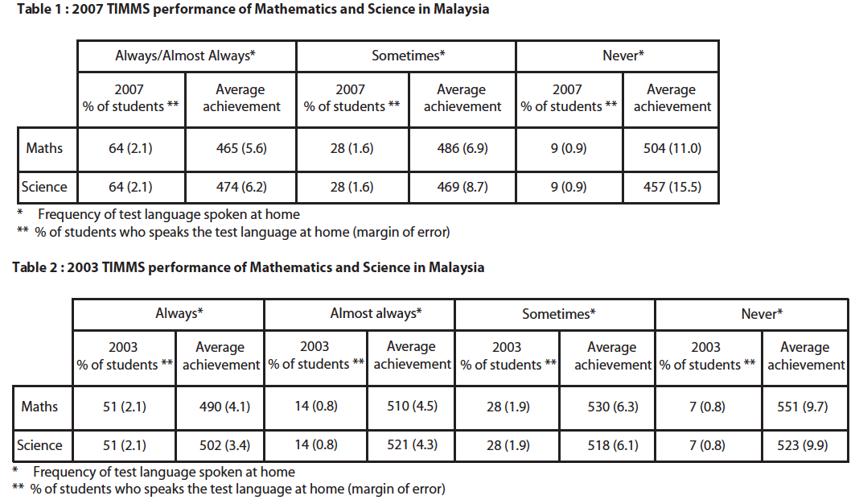

**2. Pisa 2012 results: which country does best at reading, maths and science?**

Programme for International Assessment (PISA) was initiated by the international Organisation for Economic, Co-operation and Development (OECD) (PISA, Own Portal) and it shows that Malaysia is far behind from the average in Maths, Reading and Science knowledge, even after implemented the ‘PPSMI’ policies for 10 years (table 3). This is really sad to Dr. Mahathir’s prematurely suggested vision of learning Maths and Sciences in English. In the 2013 and 2014 PISA results, Malaysia did not give any improvement but weaken instead. Let’s look at the table 3 as many countries are continuously enhancing students’ performance without changing national languages. Why Malaysia have to?

|  |  |  |  |  |
| --- | --- | --- | --- | --- |
| Table 3: Pisa results 2012 | | | | |
| **Ranking** | **Country name** | **Maths, mean score Pisa 2012** | **Reading, mean score Pisa 2012** | **Science, mean score in PISA 2012** |
| 0 | OECD average | 494 | 496 | 501 |
| 1 | Shanghai-China | 613 | 570 | 580 |
| 2 | Singapore | 573 | 542 | 551 |
| 3 | Hong Kong-China | 561 | 545 | 555 |
| 4 | Taiwan | 560 | 523 | 523 |
| 5 | S.Korea | 554 | 536 | 538 |
| 6 | Macau-China | 538 | 509 | 521 |
| 7 | Japan | 536 | 538 | 547 |
| 8 | Liechtenstein | 535 | 516 | 525 |
| 9 | Switzerland | 531 | 509 | 515 |
| 10 | Netherlands | 523 | 511 | 522 |
| 11 | Estonia | 521 | 516 | 541 |
| 12 | Finland | 519 | 524 | 545 |
| 13 | Canada | 518 | 523 | 525 |
| 14 | Poland | 518 | 518 | 526 |
| 15 | Belgium | 515 | 509 | 505 |
| 16 | Germany | 514 | 508 | 524 |
| 17 | Vietnam | 511 | 508 | 528 |
| 18 | Austria | 506 | 490 | 506 |
| 19 | Australia | 504 | 512 | 521 |
| 20 | Ireland | 501 | 523 | 522 |
| 21 | Slovenia | 501 | 481 | 514 |
| 22 | Denmark | 500 | 496 | 498 |
| 23 | New Zealand | 500 | 512 | 516 |
| 24 | Czech Republic | 499 | 493 | 508 |
| 25 | France | 495 | 505 | 499 |
| 26 | UK | 494 | 499 | 514 |
| 27 | Iceland | 493 | 483 | 478 |
| 28 | Latvia | 491 | 489 | 502 |
| 29 | Luxembourg | 490 | 488 | 491 |
| 30 | Norway | 489 | 504 | 495 |
| 31 | Portugal | 487 | 488 | 489 |
| 32 | Italy | 485 | 490 | 494 |
| 33 | Spain | 484 | 488 | 496 |
| 34 | Russian Federation | 482 | 475 | 486 |
| 35 | Slovak Republic | 482 | 463 | 471 |
| 36 | USA | 481 | 498 | 497 |
| 37 | Lithuania | 479 | 477 | 496 |
| 38 | Sweden | 478 | 483 | 485 |
| 39 | Hungary | 477 | 488 | 494 |
| 40 | Croatia | 471 | 485 | 491 |
| 41 | Israel | 466 | 486 | 470 |
| 42 | Greece | 453 | 477 | 467 |
| 43 | Serbia | 449 | 446 | 445 |
| 44 | Turkey | 448 | 475 | 463 |
| 45 | Romania | 445 | 438 | 439 |
| 46 | Cyprus | 440 | 449 | 438 |
| 47 | Bulgaria | 439 | 436 | 446 |
| 48 | UAE | 434 | 442 | 448 |
| 49 | Kazakhstan | 432 | 393 | 425 |
| 50 | Thailand | 427 | 441 | 444 |
| 51 | Chile | 423 | 441 | 445 |
| 52 | **Malaysia** | **421** | **398** | **420** |
| 53 | Mexico | 413 | 424 | 415 |
| 54 | Montenegro | 410 | 422 | 410 |
| 55 | Uruguay | 409 | 411 | 416 |
| 56 | Costa Rica | 407 | 441 | 429 |
| 57 | Albania | 394 | 394 | 397 |
| 58 | Brazil | 391 | 410 | 405 |
| 59 | Argentina | 388 | 396 | 406 |
| 60 | Tunisia | 388 | 404 | 398 |
| 61 | Jordan | 386 | 399 | 409 |
| 62 | Colombia | 376 | 403 | 399 |
| 63 | Qatar | 376 | 388 | 384 |
| 64 | Indonesia | 375 | 396 | 382 |
| 65 | Peru | 368 | 384 | 373 |

**Results and Analysis**

Despite the disagreement of many academic people on the usage of English language in these two subjects, the bi-language system has been finally implemented into the educational system of Malaysia since 2007. This model was strongly believed to be suggested by advisors from education ministry (under Tan Sri Muhyiddin Yassin’s leadership) after underwent substantial researches through their experts. However, the success of such systems will normally be evaluated after another 10 years of practices from now on. So we need to wait for another 10 years to eat the fruit, if it is correctly planted. Since the outcome is measured in terms of quality of human capitals, a qualitative measuring tool is required to evaluate such phenomena but we have none at the moment; (Catherine et al., 1999), (Mark et al., 2003) and (Yosef, 2009). In many developed countries, these two subjects (mathematics and science) are still being taught in their mother language at elementary levels. English language is predominantly used as the medium of instruction at territory levels and such. A domestic approach needs to be laid out for the perpetual means of solution rather than seeking advice from our local examination syndicates (LES), always. Besides, the important key techniques are still not discovered yet for Malaysian students; because the entire mathematical or the entire scientific educations were not established by United Kingdom or USA or any other English speaking country alone (Mathematics: Strategies….(LEP), 2004). Mathematical and scientific inventions are achieved beyond the language barriers worldwide. As such a blended type of educational model is what has to be introduced to overcome this sort of problems and it is inevitable in the fast-changing world; as to compete with the gigantic growth of scientific advancement. Although the ultimate decision-making responsibility falls in the hand of prime minister, who has conventionally getting advices from the local examination syndicate since 1978 (Cambridge Examination syndicate), has frequently missed out to notice that the United Kingdom alone can never fulfil the needs of scientific growth always. So a drastic action needs to be taken to generate highly versatile and also innovative human capitals to bring our country into the international arena. This will set the path of our nation towards the undoubted success in science and mathematics educations.

**First example is taken from the France educational curriculum, ‘how did they teach quadratic equation and its application in their mother language (French) and to what extent?’ has been translated into English for better understanding here (Lionel et al. 1990).**

The quadratic equation (am² + bm + c =0) is taught as follow:

It was the beginning of 18th century. A man from England wished to buy Land for his long time dreamt-house but the government had a rule for land buyer. If anyone wishes to buy land, then it must be a perfect square (m*m) and the buyer should fence it with his own money (see figure 2). So the man had 60 pounds in his hand and he wanted to buy land for himself. He started to calculate how many meters of land he could buy from his 60 pounds as well as its fence.

*Land, A = 1 meter * 1 meter (condition of government is that the land must be perfect square)*

*= 1 m²*

*1 mm*

*And he has to fence it with his own money. So*

**Area**

*1 mm*

*1 mm*

*Fence, F = 1 meter + 1 meter + 1 meter + 1 meter*

*= 4 m*

*1 mm*

*So he wrote an equation for his 60 pounds.*

*60 Pounds = Area + Fence*

Figure 2: Area and fence calculation

*60 = m² + 4m*

*0 = m² + 4m – 60*

Now a =1 ; b= 4 ; c= -60. He solved the equation and consequently managed to tell how many meter squared of land and fence could have been purchased for his 60 pounds. Now the astonishing factor is that no matter which language we used to study math but it has to be true knowledge to understand the entire things after all. Only then, we can innovate the world with scientific improvement. Let’s look at the current teaching technique in Malaysia! The school teachers will teach us to factorize it, such as:

*a² + 5a + 6 = 0*

*( a + 2 ) ( a + 3 ) = 0*

*a = -2 ; -3*

(This technique can be taught in any language because the solution remains unchanged, as it is just in digits, what matters language then?)

But none of the teachers in Malaysia teaches us how it was discovered or where to apply it otherwise! Without knowing the existence, none will know the ending whatsoever mean thereafter. So the current mathematical and scientific educations are absolutely focusing on problem-solving-techniques than the original story-telling-concepts. Solving the multiple questionnaires and home works will lead a student to be trained well but not to be an educated or a progressed one (Pip et al., 2005). There are alternate systems for poor English speaking people in USA. Such as the guide, Mathematics: strategies for teaching limited English proficient (LEP) students, Virginia Department of Education Division of Instruction April 2004.

**Second example is taken from the British IGCSE educational curriculum, ‘how did they teach trigonometric in their mother language (English) and to what extent?’ has been summarized for easiest understanding here.**

The trigonometric equation (sin 2 θ + cos 2 θ = 1) is taught as follow:

Around 1900 AD, Professor Sine and his student Scholar Cosine have travelled around the world with one of the oldest FORD automobile, covering a few landmarks.

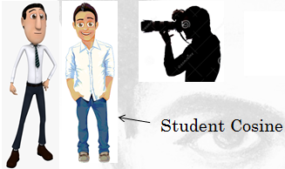

Before they leave their home country, they took picture as both are in the same height.

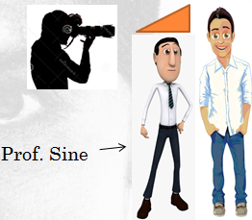

After come back from a long journey, they took picture again. Prof. Sine was little shorter than Scholar Cosine.

Figure 3: A turning point in Professor Sine and his collaborator Scholar Cosine life

Then the photographer asked them, “Will you people analyze the Pythagoras theorem as to why one man is taller than another in this travelling period? Prof. Sine said: We will! That’s why today we have the wonderful formula of sin2 θ + cos2 θ = 1 (figure 3). Professor Sine and his student (Scholar Cosine) have analyzed the Pythagoras theorem, thereby. Prof. Sine was standing on the y-axis of Cartesian coordinate while Scholar Cosine was laying down on the x-axis. Professor Sine said that he can see the hypotenuse (r) which is common to both sides and a phase angle relevant to it. So he said that y-axis is now occupied with r sin and a phase angle of θ degree. Similarly the Cosine said that x-axis is now occupied with r cos and a phase angle of θ degree.

*As such, y = r sin θ and x = r cos θ. Now they substituted these equation into Pythagoras theorem, Z 2 = X 2 + Y 2 ,*

*Z2 = (r cos θ)2 + (r sin θ)2*

*Z2 = (r2 (cos2 θ) + r2 (sin2 θ))*

*Z2 = r2 [(cos2 θ) + (sin2 θ)]*

*Z2 / r2 = [(cos2 θ) + (sin2 θ)]*

*1 = cos2 θ + sin2 θ*

**Third example is taken from the American K-12 educational curriculum, ‘how did they teach logarithmic in their mother language (English) and to what extent?’ has been summarized for easiest understanding here.**

The topic, Logarithmic is taught as follow:

Lord Napier, Scotland, AD 1550, had a gardener whose job was to plant trees according to his prescribed patters. With a condition that as for the first square meter, the gardener has not to plant anything as the Lord will stand and observe the shape of garden from the first square meter of land. Lord Napier Told: “ I’m willing to give you only the exact number of seed for. One meter squared area deserves 1 seed of plant. So calculate the area first pls! ”

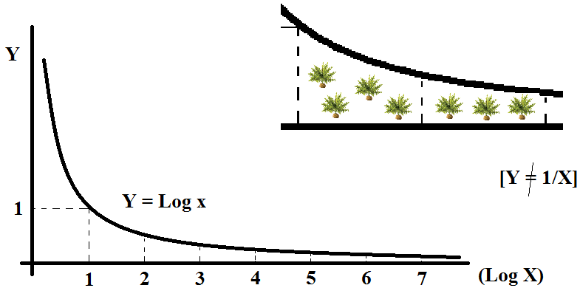

Log 1 = 0

Log 2 = 0.693

Log 3 = 1.098

Log 4 = 1.386

Log 5 = 1.609

Log 6 = 1.791

Log 7 = ……..

Figure 4: Logarithmic scale for areas

With the above computation, the uneducated gardener has predicted the following formulas, which is later tally with exponential analysis in maths (figure 4).



Lord Napier told the gardener: “I’m boring with your unimaginable shapes, so, you better calculates the log x = 1 meter squared, then I give you enough seed for that”. Gardener knew that Log x =1 m **2** is between Log 2 = 0.693 to Log 3 = 1.098 (figure 5). At last he got the value as,

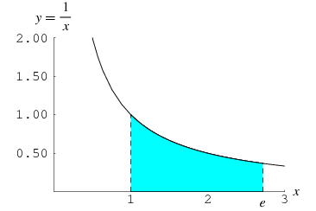

Figure 5: Natural Logarithmic scale for areas, finding the value of ‘e’

But in Malaysian SPM curriculum, the course coordinators have hardly explained what is sine and cosine or even to a tangent, after all. Quadratic and Logarithmic approaches are never once explained by KBSM authors or any other books but merely hard computing exercises. It should be noted here that the mathematics and science educations have to be improved according to Tun Dr. Mahathir’s vision but to what extent and in which language are remained hypothesis. So if we follow the mother language model for mathematics and science educations, then Malay people should learn and practiced it in Bahasa Malaysia, Chinese people should go through one of the Chinese language, preferably mandarin and Indian should go through one of the Indian language, preferably Tamil.

**The Malaysian Higher Educational Blueprint 2015-2025 (Summary)**

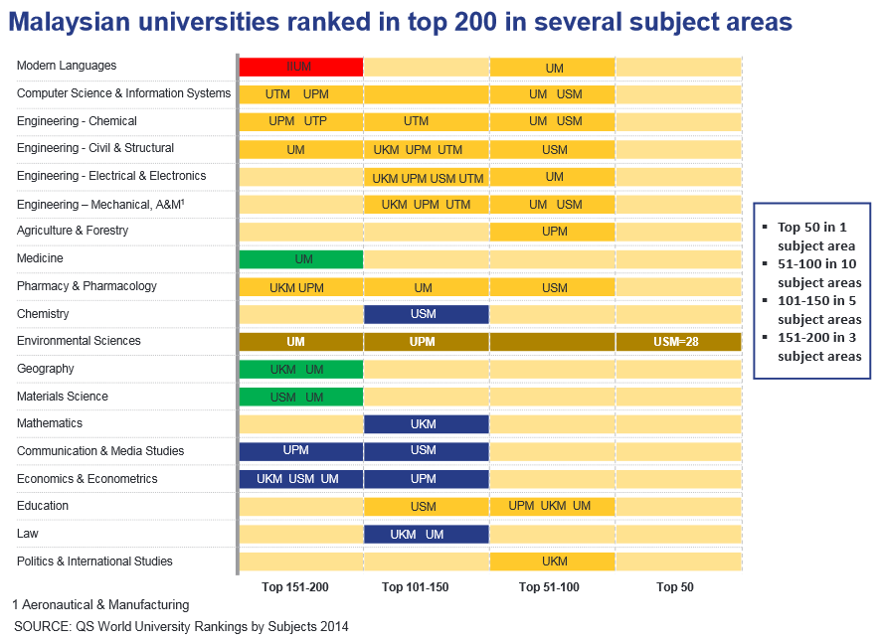

Figure 6: Cut and pasted from blueprint 2015-2025

‘The Malaysian higher education system has grown from strength to strength over the past few decades. Over the last ten years alone, the system has made significant gains in student enrolment, raised in global recognition on key dimensions such as research publications, patents, and institutional quality, as well as become a top destination for international students. These achievements are a testament to the drive and innovation of the Malaysian academic community, the support of the private sector, as well as the deep investment the Government has made.” – Copied and reproduced here from the Malaysian Educational Blueprint 2015-2025.In this set of document, the objective is clearly mentioned that Malaysia is striving to achieve high standards in education. See figure 7, which was cut and pasted from blueprint, itself (Malaysian Educational Blueprint 2015-2025).

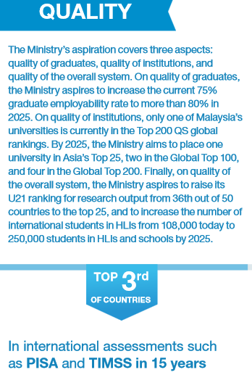

Figure 7: Cut and pasted from blueprint 2015-2025

Given information is clearly misleading the Malaysian citizens, as if it has been planned for 15 years, and then the time frame must be dated from 2015 to 2030. Alternatively, if it has been already achieved by now, then why the PISA official record indicates that we are far behind from the league table? Why The THES ranking is not taken into account but QS? Who to blame in this case as there is no transparent system after all! Academician argues about it frequently nowadays! So let the Educational excellence free from politics.

**Conclusion**

Gaining a global standard and recognition in mathematics and science education is always being our dream as we run behind politicians to finalise our destiny. Tun Dr. Mahathir was right in dreaming the vision but finding the absolute solution was not laid at his hand as he was leaving the prime ministerial post by the time when the matter was planned to be implemented in national educational route. Thereafter the experiment went wrong due incompetent board members and due to multiple feedbacks which have created severe lack of confidence in the tuning process. This is what made every citizen to worry about the outcomes regardless of religious practise or racial identity. Recently our Johor Sultan said that we should learn from Singapore as how to establish educational policies for global coherence. Hence, in order to excel in Maths and Scientific Education, Malaysian should have proper policies together with continuous guidance, perhaps from somebody who has already implemented such efforts in their countries. This can be truly possible when the educational decision is given to academic people rather than utterly giving it to politicians who knew nothing about the risk. Still some politician argue that Malaysian need Wawasan schools to boost national unity although fail in the global competition. Hence a well-planned, systematic approach is what can solve our problem and may lead to enlightenment someday.

**Reference**

Catherine, M. and Gretchen, B. R., (1999). Designing qualitative research, 3rd edition, *Sage Publication*.

Lionel, S., Frederic, T. and Coralie, S., (1990).The most beautiful mathematical formulas. Published by John Wiley and Sons Inc.

Mathematics: Strategies for teaching limited English proficient (LEP) students, Virginia Department of Education Division of Instruction April 2004

Mahathir Mohamad Biography : https://en.wikipedia.org/wiki/Mahathir_Mohamad

Mark, L. M. and Karen W.S., (2003). The five-question method for framing a qualitative research study. *The Qualitative Report*, Volume 8 Number 3 September Edi, 447-461.

Muhyiddin ‘baffled’ by Malaysians’ poor grasp of English – Malaymail News: <http://www.themalaymailonline.com/malaysia/article/muhyiddin-baffled-by-malaysians-poor-grasp-of-english#sthash.kvMnnlcU.dpuf>

Pip, N.B. and Bill, B., (2005). The relationship between english language and mathematics learning for non-native speakers, Unitec New Zealand.

Pengajaran dan Pembelajaran Sains dan Matematik Dalam Bahasa Inggeris, PPSMI (*the teaching and learning of science and mathematics in English*) b<https://en.wikipedia.org/wiki/PPSMI>

PISA, Own Portal: <http://www.oecd.org/pisa/>

TIMSS, Own Portal – 2015: <http://www.iea.nl/timss_2015.html>

The Malaysian Educational Blueprint 2015-2025: <http://hes.moe.gov.my/event/docs/4.%20Executive%20Summary%20PPPM%202015-2025.pdf>

Yosef Jabareen, (2009). Building a conceptual framework: philosophy, definitions, and procedure. *International Journal of Qualitative Methods 8(4)*